
Development Request
Aria Systems

CP# 200147

AMENDMENT TO STYLE PURCHASE ORDER ISSUING SCREEN FOR MULTIPLE STYLES ON A PO

New Program Template Description

New Program Template

Amendment to CP 200147
Product: | Aria 2.7
Module: | PO – Style Purchase Order
Customer name: | Alena Ltd
Installed Modules: | AR, IC, SO, PO, SA, RM, SM, MA, SR, AP, GL
Parameters setting: | Multi-Currency = Y  Multi-warehouse = Y  Material Costing method = Lot  Style Costing method = FIFO  Extended sizes = No  Style number format = 12 characters style code  6 characters colour

Details Section
Screen Name: STYLE PO ISSUING SCREEN

Screen Objective: Allow for multiple styles.

Existing Initial situation: CP 200147

Description ( Processing ) :
In the past the customer would only have two styles on a sales order to accommodate more than eight sizes. And in such case both styles would have different size scale codes. The above scenario will still apply and the processing for this scenario should continue as before

Now there is a further situation where there will be an order with different style numbers to accommodate different fits (another dimension e.g SHORT,REGULAR,LONG). As the customer does not have extended sizes enabled, they will key in 2 separate style numbers or maybe 3 if there are three fits but in this scenario the size scale on all 2 or 3 of these different style numbers will be the same.

The issuing screen needs to separate the lines for the FABRIC so that they show individually for each of the two or three styles and for each colour.

See example screen showing existing situation on next page

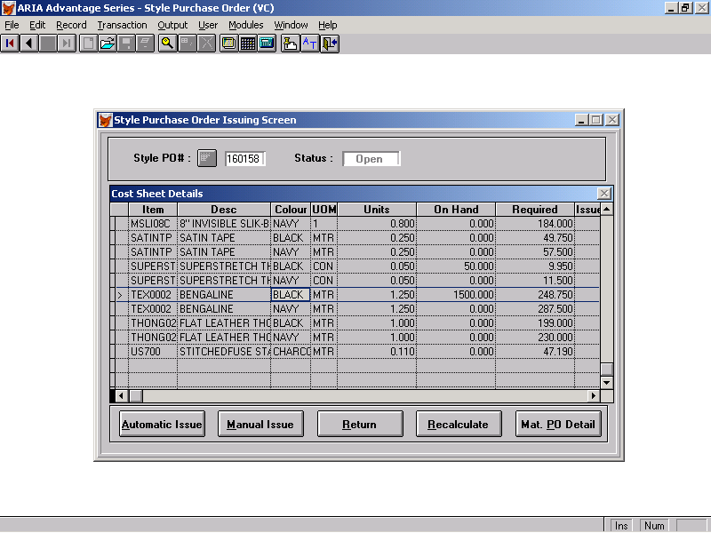

The above screen relates to how the issuing screen looks now. In this example PO 160158, there are two styles.

Style T9642 in BLACK and NAVY uses fabric TEX0002 in BLACK and NAVY with a bom.nbomtotqty (costing) of 1.20 for each colour. The PO quantity for BLACK = 109 and NAVY = 111

Style T8240 in BLACK and NAVY uses fabric TEX0002 in BLACK and NAVY with a bom.nbomtotqty (costing) of 1.25 for each colour.
The PO quantity for BLACK = 90 and NAVY = 119

So where there are multiple styles on the PO, look at the size scale of the first line and if there are other styles on the PO with that size scale, the fabric requirements ie CTKTBOM.CCATGTYP = F must be shown individually for each style/colour. The trim details will remain as shown as the trim cost sheet details for the trims will be the same for both styles.

The issuing screen should therefore show as follows for the fabric

Item Description Colour UOM Units On Hand Required Issued
TEX0002 BENGALINE BLACK MTR 1.20 1500.00 130.800 136.80
TEX0002 BENGALINE BLACK MTR 1.25 1500.00 112.500 112.50
TEX0002 BENGALINE NAVY MTR 1.20 0.00 133.200
TEX0002 BENGALINE NAVY MTR 1.25 0.00 148.750

The above data can be picked up from the BOMLINE file where the detail requirements by style are held.

For the Primary fabric, in order to issue, the user will click on the first line above and Manual issue (note changes re multiple primary fabrics on a style/colour to be taken into account) If the quantity issued is more or less than required and the user later recalculates the quantities, the trims should be automatically recalculated related to that style. For example, the first line above relates to style T9642. Therefore, if the user were to issue a quantity of 136.80 and then recalculated and accepted the extra 5 units, then the trims should recalculate also based on the extra units.

The re-calculation screen will show the quantities based on the BOMLINE style/colour that the fabric line relates to.

The recalculation screen will be either a single line screen as before if the style relating to the fabric line appears only once on the order. If the style has multiple lines on the order, then the multi-store/pack screen will appear.

As there are now two styles involved above, then the recalculation screen (either the single line screen or multi-store/prepack screen)will need to show the correct style number to which it is referring.

The issued quantity for each of the fabric lines for each of the style/colour on the PO needs to be recorded separately. Currently only the total is recorded in CTKTBOM.

Add two new fields to BOMLINE called ISSUE_QTY and USED_QTY which will hold the issued and issued minus returned quantities relating to each style/colour. This is necessary only for the fabric.

Other changes to be made to this screen as follows:-

- Reduce the width of the value columns so that the Used and Issued column data can be clearly seen without the necessity to scroll across.
- Swap the Issued and Used columns so that Used appears first
- The fabric items should appear at the top of the list followed by the trims
- Automatic Issue should not include fabric even though fabric orders may be assigned to sales orders in MAPOALO
- If the user amends the Units field for an item, the required quantity is recalculated. If there is already a quantity issued and that quantity is greater than the required quantity, the screen should prompt ‘ you have issued nnn MTR more than required, do you wish to return this quantity?’ (note nnn followed by UOM use)

If the user responds Y to this prompt, the screen will prompt with the warehouse code from which the item was issued (items will be issued from only one warehouse). The displayed warehouse will have a drop down box which will allow the user to select an alternative warehouse. Once the user selects the warehouse and then clicks on an OK button, the quantity will be returned to the specified warehouse and will retain the original lot number

If the quantity issued is less than the quantity required having changed the units, the message ‘you have issued nn MTR less than required, do you want to issue this quantity’. If the user selects Y, then if the items is a fabric or a trim without a PO assigned to the SO in MAOALO, the manual issue screen will appear showing the required quantity as the extra quantity to be issued. The user can then select the lot from which this item is to be issued and click on the issue button. If the item relates to an automatic issue, then the extra quantity will be issued with no further prompting (provided there is sufficient on hand)

If the user responds N to the above messages then the issued quantity will remain as is.
Also when doing returns using the Returns button and when the returns figure has been keyed, the system should display a pop-up of locations displaying the Open Lots warehouse i.e. the warehouse from which the item was issued as the default.

5. Add the ‘Issuing Screen’ option to the Options list on the Purchase Order screen so that this screen can be accessed directly either from clicking on the PO button on the Generate PO from sales orders transactions, and then Options- Issuing Screen or from Transaction – Style Purchase Orders – Purchase Order and Options- Issuing Screen.
- Have an Option item on the Issuing screen that allows access to the Po Cost Sheet

Questions 06/08/2003
  - You have mentioned the following “As the customer does not have extended sizes enabled, they will key in 2 separate style numbers or maybe 3 if there are three fits but in this scenario the size scale on all 2 or 3 of these different style numbers will be the same”
In the new scenario the program will work if and only if we have two or more styles with different codes and have the same scale code. Please confirm.

Yes, for the above case but the current case should still be accommodated ‘ In the past the customer would only have two styles on a sales order to accommodate more than eight sizes. And in such case both styles would have different size scale codes. The above scenario will still apply and the processing for this scenario should continue as before’

  - Regarding point # 5 in page 6, will be applied in both scenarios the existent one and the new one?

Yes

  - You mentioned the following “Also when doing returns using the Returns button and when the returns figure has been keyed, the system should display a pop-up of locations displaying the Open Lots warehouse i.e. the warehouse from which the item was issued as the default”
We will display the a pup up of the ware house defaulted by the issued ware house as a display only in other words it will be disabled. Please confirm as our standard return screen.

The user needs to be able to choose a warehouse to make the return. The default will be the warehouse from which the lot was issued. The user should then be able to select another warehouse from the pop-up list. This will generate a new lot record at that warehouse

